**Verification of Kirchhoff's Voltage and Current Laws**

**Lab #2**

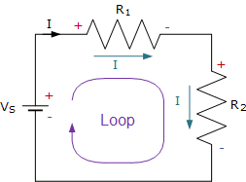

ECE 1101 Lab, Section 6

Date: Thursday September 5th, 2019

Kyler Martinez, Daniel Tan

Equipment Used In The Experiment:

* Lab-Volt Power Supply
  + Make/model: 1224 AC/Dual DC Power Supply
  + Serial Number: N/A
* Keysight 4 ½ Digital Display Multimeter
  + Make/Model: U3401A
  + Serial Number: MY56150032
* Fluke Digital Multimeter
  + Make/Model: 8010A
  + Serial Number: 56708

Materials Used In The Experiment:

* Breadboard
* 1kΩ Resistor
* 3.3kΩ Resistor
* 6.8kΩ Resistor

Objective:

Students will validate both Kirchhoff’s Voltage and Current law while using a breadboard circuit and taking direct breadboard and current measurements. Students will also validate that each branch in parallel drop the same voltage.

Background Theory:

The background theory used in the lab are Kirchhoff’s Current and Voltage laws which state that the sum of all the voltage drops or rises in a loop on a circuit will equal zero and the sum of all currents entering and leaving a junction will equal zero.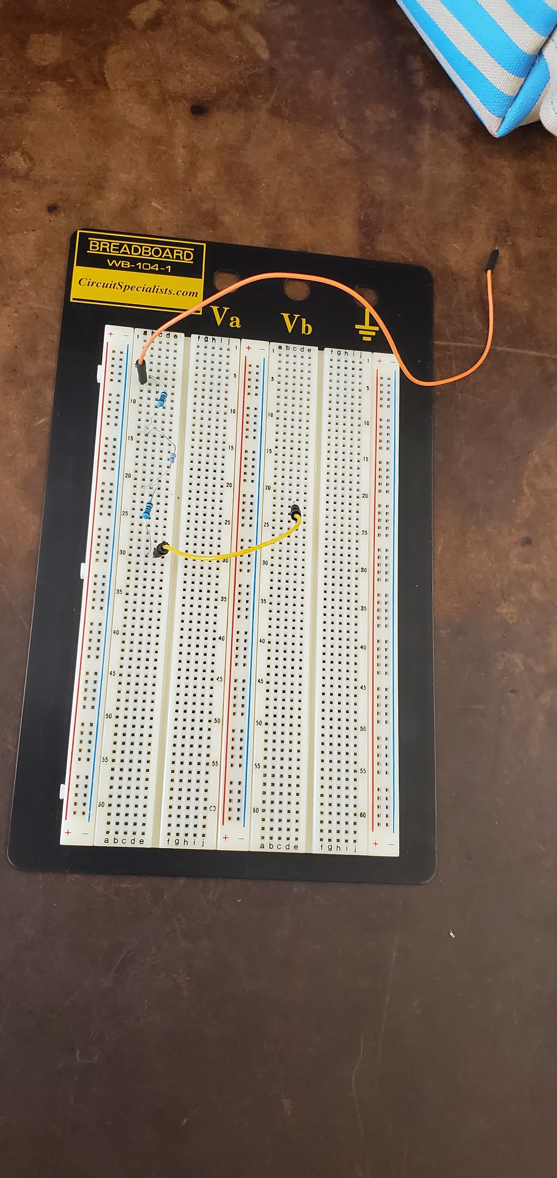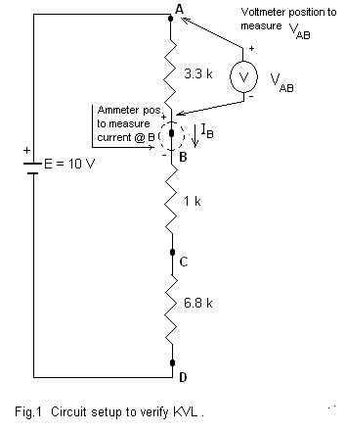

Procedure:

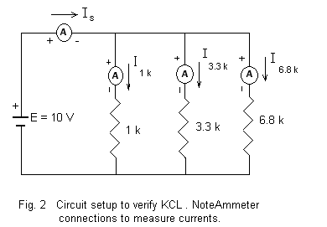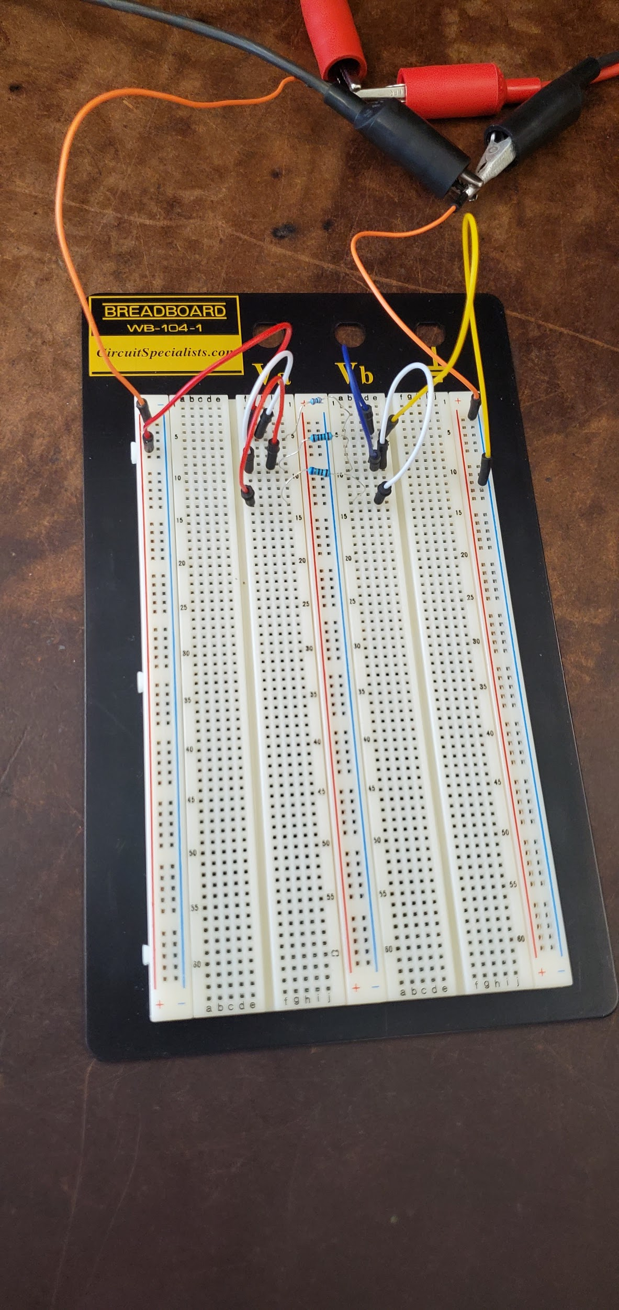To validate KVl, use the breadboard and build the circuit showcased in Figure 1 and then record the Voltage drops across the three resistors and the currents going through them. To validate KCL, we used the breadboard and built a circuit to look like figure 2. We then took measurements of each of the currents entering the resistors and the voltage drops of each resistor.

Data:

Resistor Values

|  |  |  |  |
| --- | --- | --- | --- |
|  | 1 kΩ Resistor | 3.3 kΩ Resistor | 6.8 kΩ Resistor |
| Resistor Values | .9938 kΩ | 3.297 kΩ | 6.747 kΩ |

Circuit 1

|  |  |  |  |  |
| --- | --- | --- | --- | --- |
| Voltage Drops | VAB = 2.9948 V | VBC =.9027 V | VCD =6.128 V | (E)VAD = 9.99 V |
|  | VAD = 10.031 V | VBD =7.035 V | VCD =6.130 V | VDD = 0 V |
| Currents | IA = .8972 mA | IB =.8971 mA | IC =.8973 mA | ID = .8971 mA |

VAD -VAB - VBC-VCD= 9.99 - 6.128 - .9027 - 2.9948 = -.0355 V

IA ≈ .8972 mA ≈ IB ≈ .8971 mA ≈ IC ≈ .8973 mA ≈ ID ≈ .8971 mA, IAvg= .897175

VAB =VAD - VBD : 2.9948 V ≈ 10.031-7.035 ≈ 2.996 V, Percent Error: .040%

VBC =VBD - VCD : .9027 V ≈ 7.035-6.130 ≈ .905 V, Percent Error: .255%

VCD =VCD - VDD : 6.128 V ≈ 6.130-0 ≈ 6.130 V, Percent Error: .033%

Circuit 2

|  |  |  |  |  |
| --- | --- | --- | --- | --- |
| Voltage Drops | E= 10.01 V | V1k = 10.0 V | V3.3k =9.999 V | V6.8k =9.999 V |
| Currents | IS = 14.578 mA | I1k =9.999 mA | I3.3k =2.9263 mA | I6.8k = 1.4535 mA |

IS - I1k - I3.3k - I6.8k = .1922 mA

E ≈ 10.01 V ≈ V1k ≈ 10.0 V ≈ V3.3k ≈ 9.999 V ≈ V6.8k ≈ 9.999 V, VAvg= 10.002

Conclusion:

Ultimately our experiment yielded results that validate KVL and KCL, along with the other objectives. In circuit one, subtracting all the voltage drops from the voltage yield a result of -.0355 V, which is extremely close to zero and essentially validates the Kirchhoff’s Voltage law. This small error may be the result of running the voltage source for a long period which could allow for the voltage to fluctuate which could have thrown our data off. We were able to show that the current going through elements in series is the same for all elements, with small deviation. However when taking the average of the currents it shows the currents of the elements being extremely close to the average. Finally, we showed that VAB, VBC, and VCD, were all roughly equal to the difference in the voltage drops between the first point and the reference point, and the second point and the reference point. The percent error can be attributed to instrument value fluctuation and electromagnetic anomalies that may occur and we don’t know how to prevent from occurring.

In circuit two, we yielded less optimal results to validate Kirchhoff’s Current Law, subtracting all the currents going into the different branches from the voltage sources yielded a result of .1922 mA. That value is close to zero mA but isn’t as close as we would have wanted it. Fluctuation could have easily occurred since we spent a longer duration of time getting the readings since we had to measure the current going into each resistor and this could have easily allowed for the voltage to increase or decrease while we weren’t aware. The quality of our materials could have contributed to this or simply it could be experimental uncertainty that’s the cause of our results. The value that deviated the most from the theoretical value was the current reading going into the 3.3 kiloohm resistor and this could have been the result of the resistor being put in improperly or general wear and tear if components. However, our results for the voltage drop across each resistor was much better with the most voltage drops being about .07 percent away from the average value. This validates objective 5 and shows that the voltage drop of all the elements in a parallel branch has the same voltage drop, this also plays into the validation of Kirchhoff’s voltage law in the way that each branch must drop the same voltage so that sum of all voltage drops or rises would equal zero.

**Verification of Kirchhoff's Voltage and Current Laws Post Lab #2**

Results:

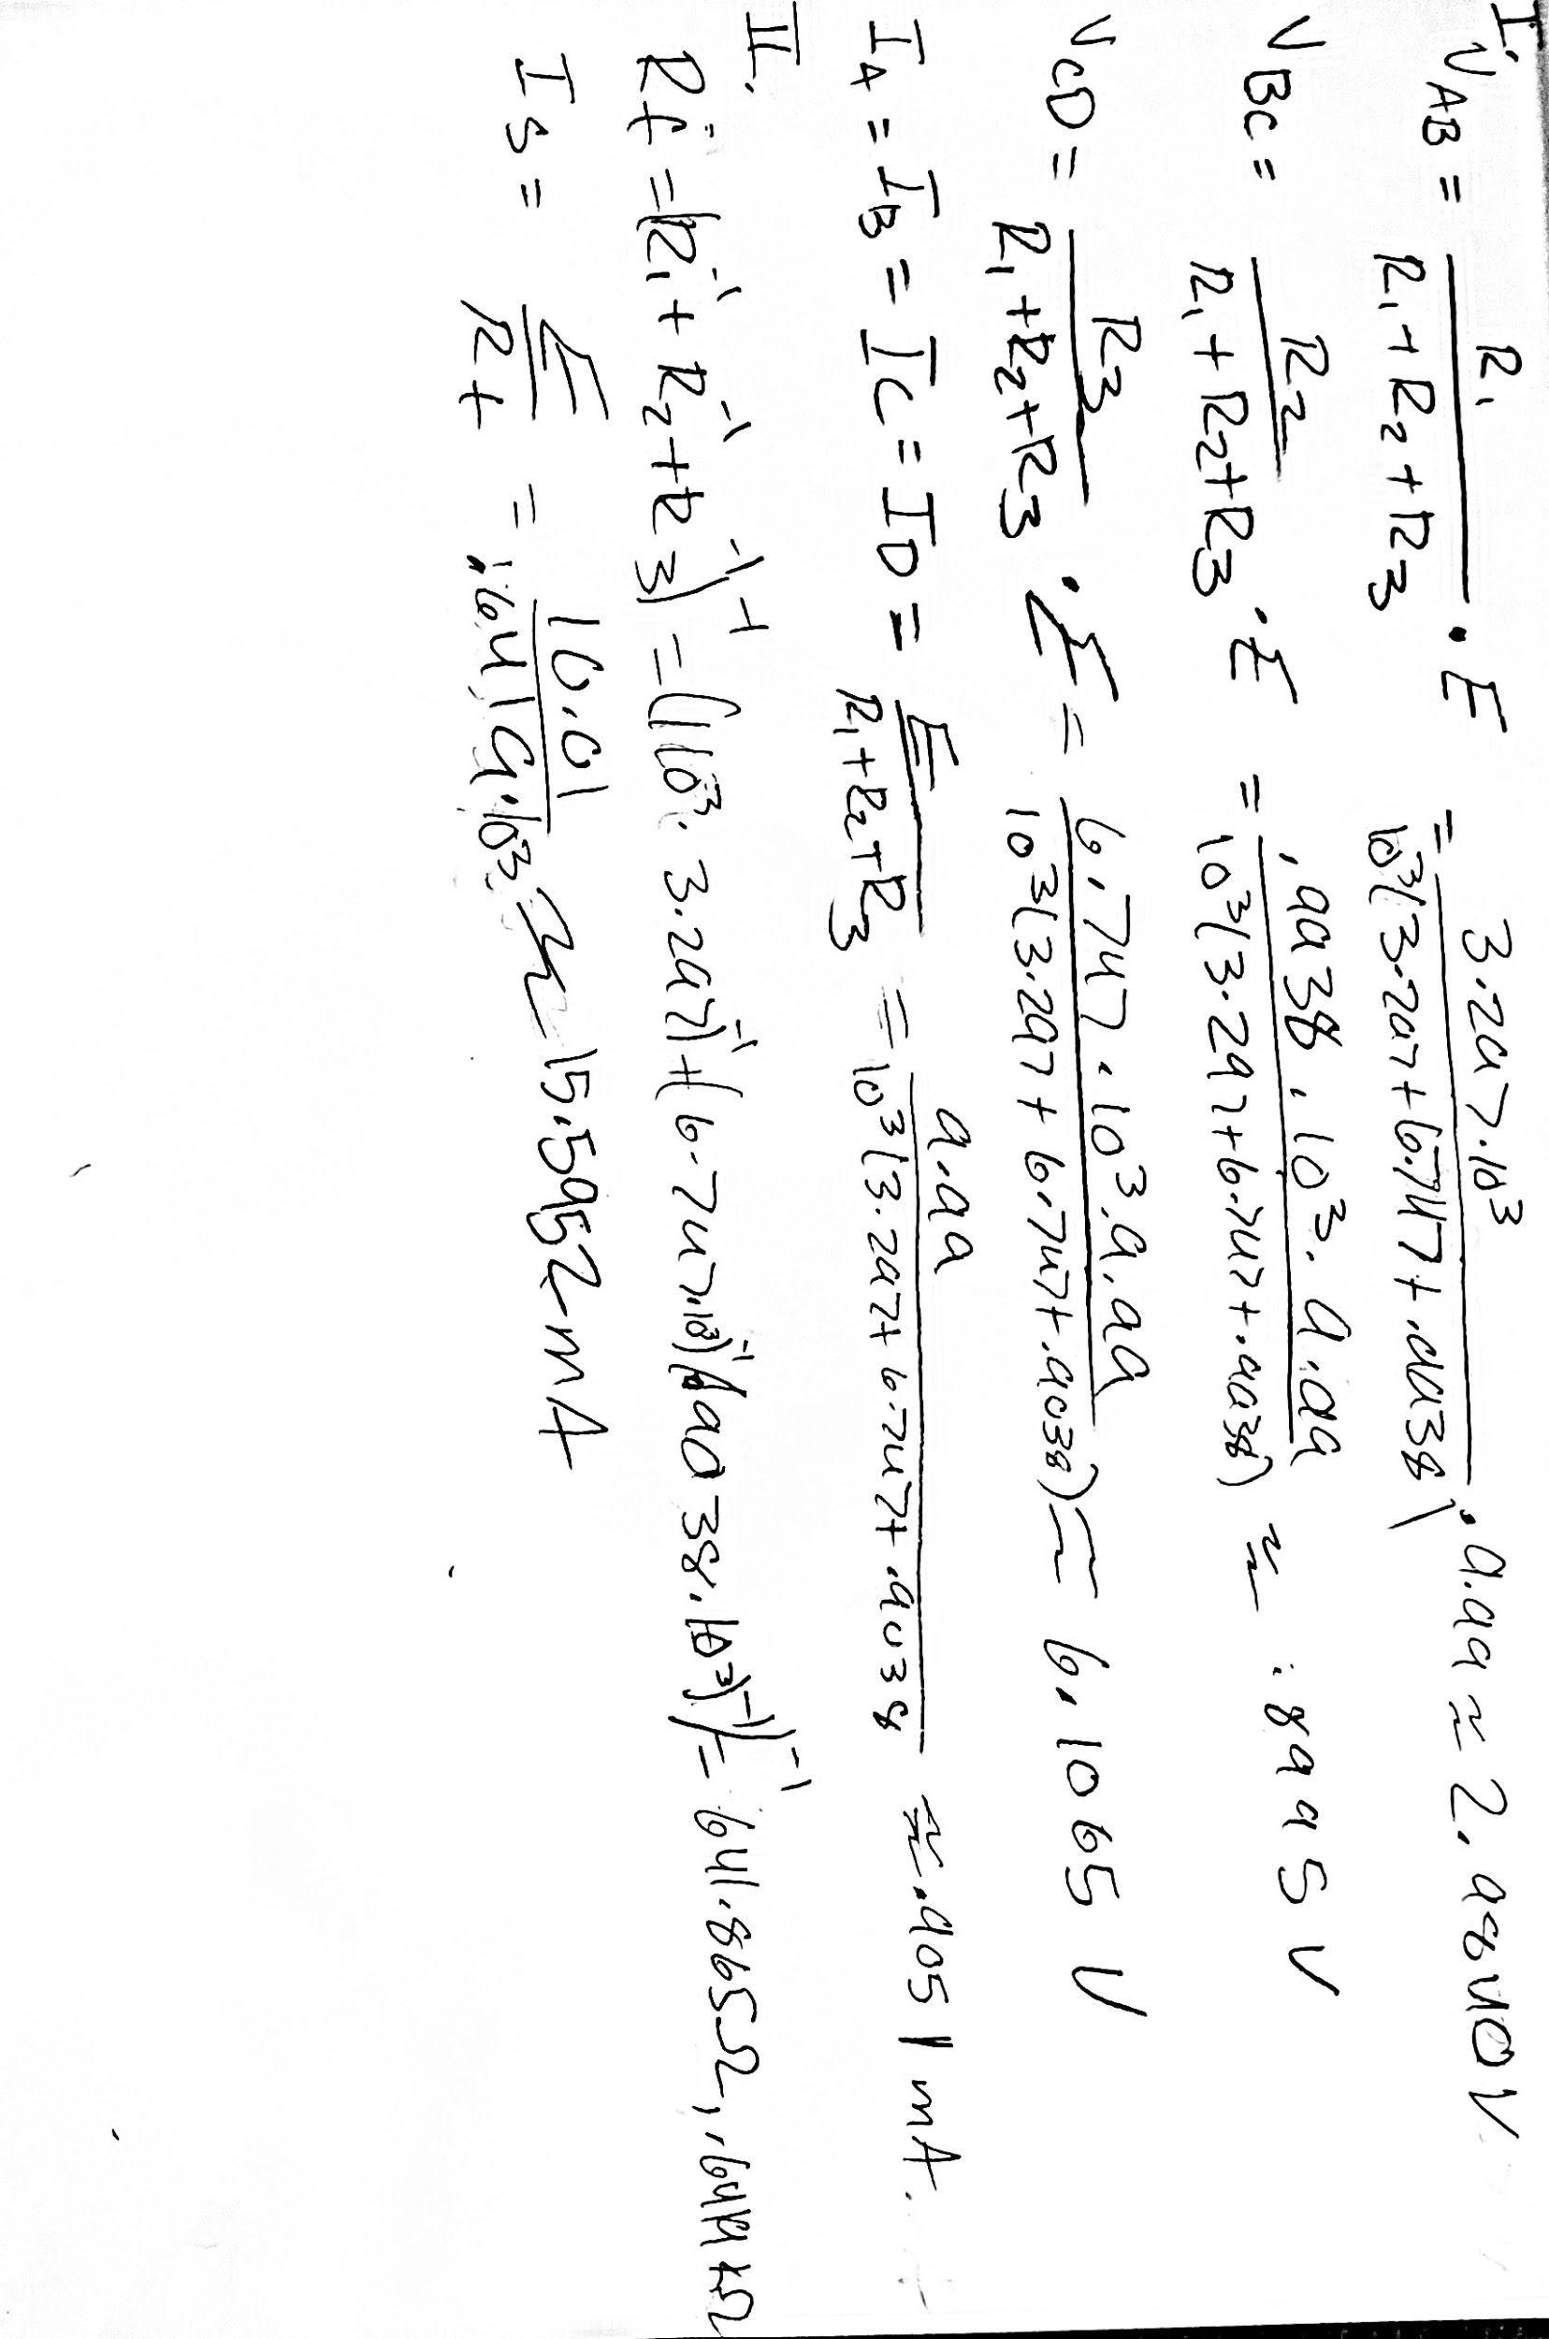

|  |  |
| --- | --- |
| Circuit I | Circuit II |
| VAB % Error = -.361% | IS Percent Error = 6.5224 % |
| VBC % Error = -.354% |  |
| VCD % Error = -.351% |  |
| IAverage Percent Error = .883 % |  |

Conclusion:

For the first circuit we were able to prove that the voltage division equation works with a small percent error of roughly -.35 to -.36 percent error for the voltages. When using the second equation to find the current going through each resistor, we got an average of .883 percent error. We were able to show this equation worked with a relatively small percent error. These small errors could’ve been the result of fluctuation when getting our readings or other analogies that we didn’t know or could have accounted for.

For the second circuit we weren’t able to prove that the current going through the system was equal to the voltage of the source divided by the sum of the resistors as effectively as we had wanted. When calculating percent we determined we had a 6.5224% error, which is more than likely the result of human error when getting a current reading. This would have the result of accidents like to properly fitting the resistors into the breadboard after taking measurements which would have changed the resistance of the board and resulted in a different reading. Fluctuation of the machines is still at play in our readings but wouldn’t have contributed to a percent error as high as about 6.5%.